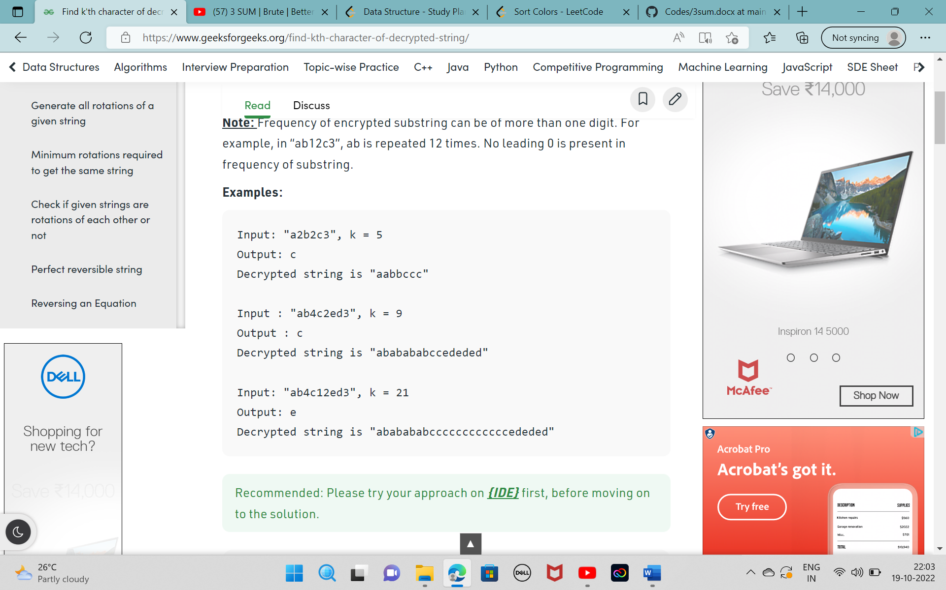

char encodedChar(string str,int k)

{

string f="";

string temp;

int freq=0;

for(int i=0;str[i]!='\0';){

temp="";

freq=0;

while(str[i]>='a' && str[i]<='z'){

temp.push_back(str[i]);

i++;

}

while(str[i]>='1' && str[i]<='9'){

freq=freq*10+str[i]-'0';

i++;

}

for(int j=0;j<freq;j++){

f.append(temp);

}

}

if(freq==0){

f.append(temp);

}

return f[k-1];

}

// Driver program to test the string

int main()

{

string str = "a2b3";

int k = 3;

cout << encodedChar(str, k) << endl;

return 0;

}